**Working with Bind & Reverse Shells**

# Section 1: Remote Shells using NetCat

**Step 1:** Use the “ip addr” command to obtain its IP address on eth0.

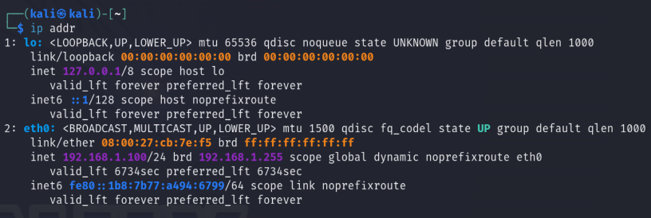

**Step 2:** Copy the Windows version of Netcat over to Metasploitable 3.

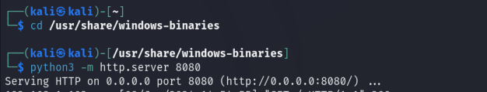

**Step 3:** On Metasploitable 3, open the web browser and go to http://192.168.1.100:8080.

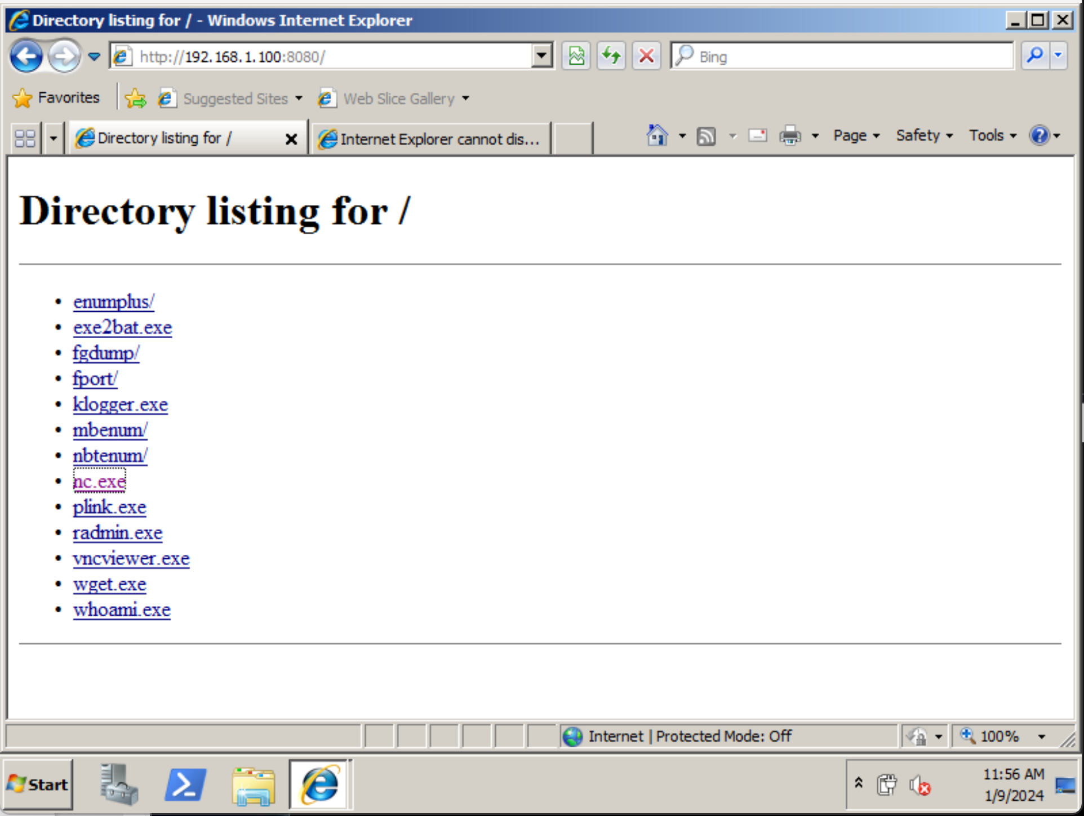

**Step 4:** Download the nc.exe file from Kali Linux.

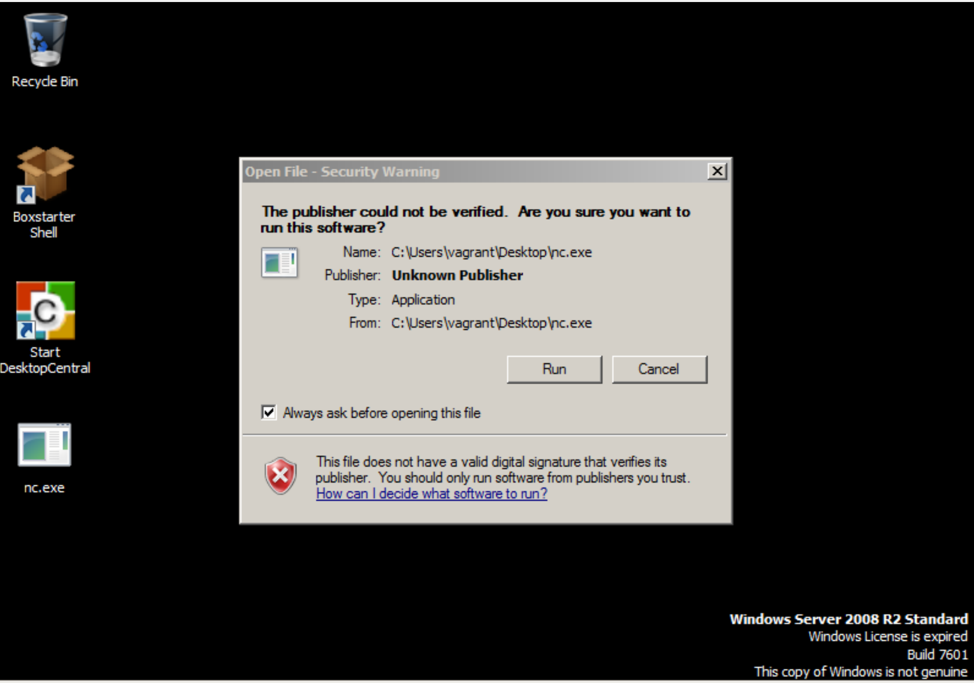

**Step 5:** Start a listener (server) on Kali Linux.

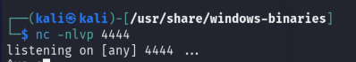

**Step 6:**  Open the Windows Command Prompt and connect to Kali Linux (listener).

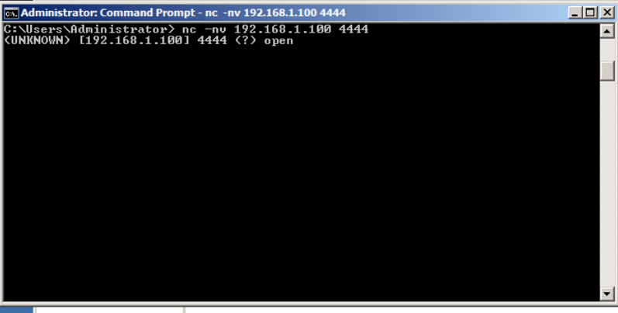

**Step 7:** Type messages into the Metasploitable 3 server and see them appear on the Kali shell.

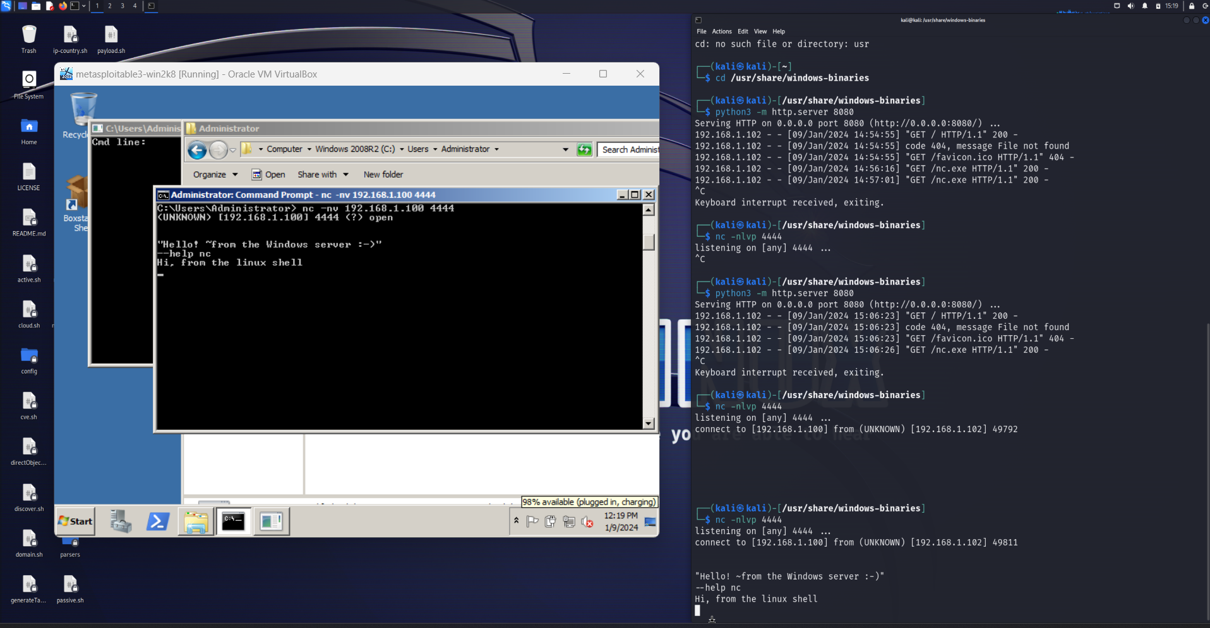

# Section 2: Creating a Bind Shell

**Step 1:** Start a listener that binds to the native bash shell.



**Step 2:** Open the Windows Command Prompt and establish a Netcat connection to Kali Linux (listener).

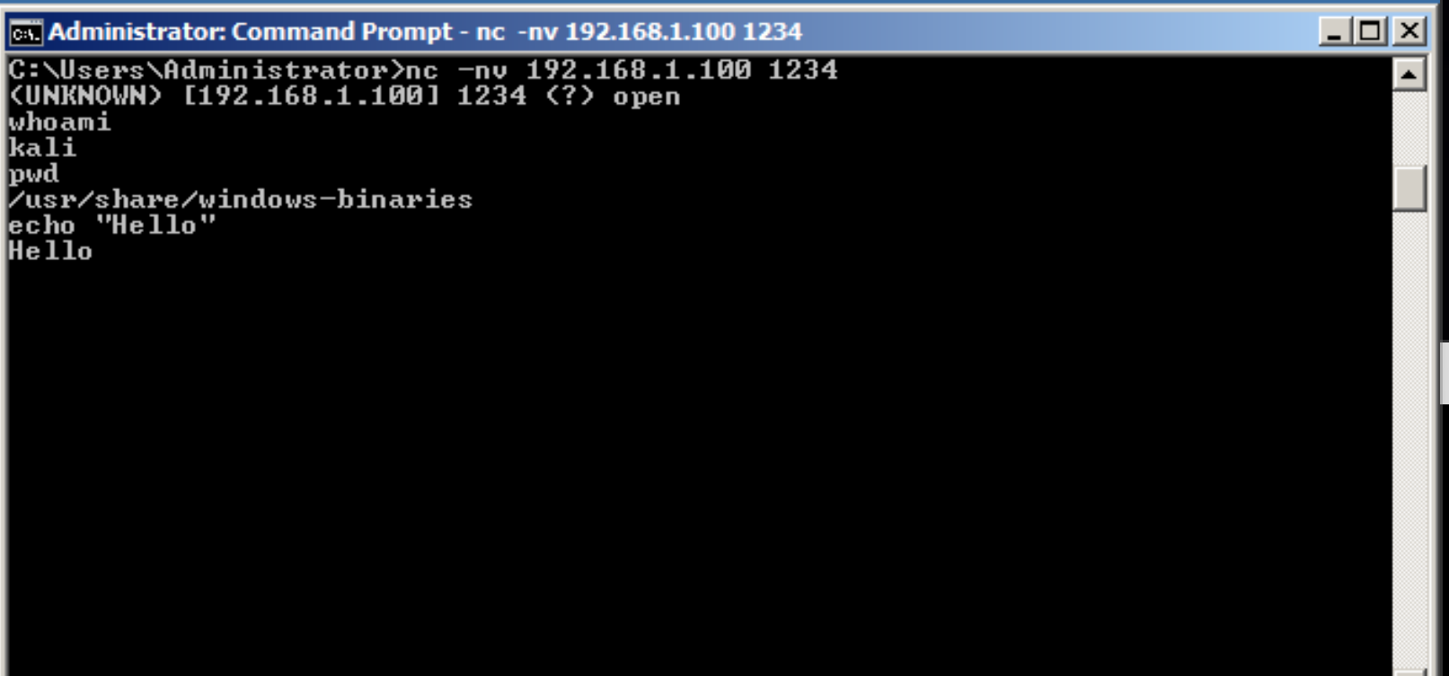

**Step 3:** Execute Linux-based commands from the Windows Command Prompt.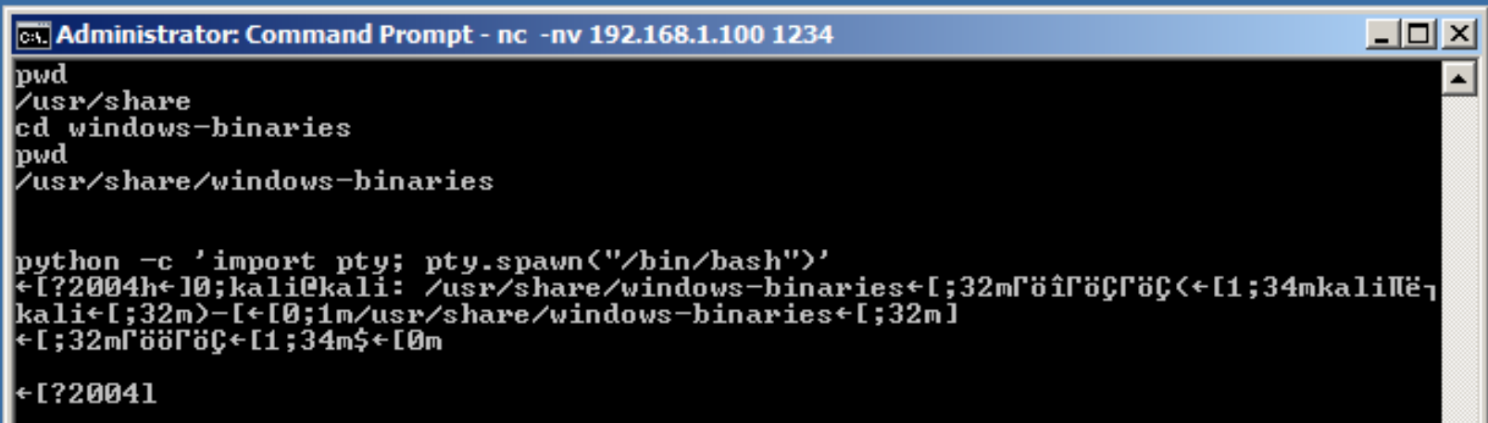

# Section 3: Creating a Reverse Shell

**Step 1:** Open the Terminal and set up a listener using Netcat.

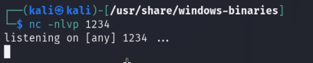

**Step 2:** Open the Windows Command Prompt and create a reverse connection to the listener.

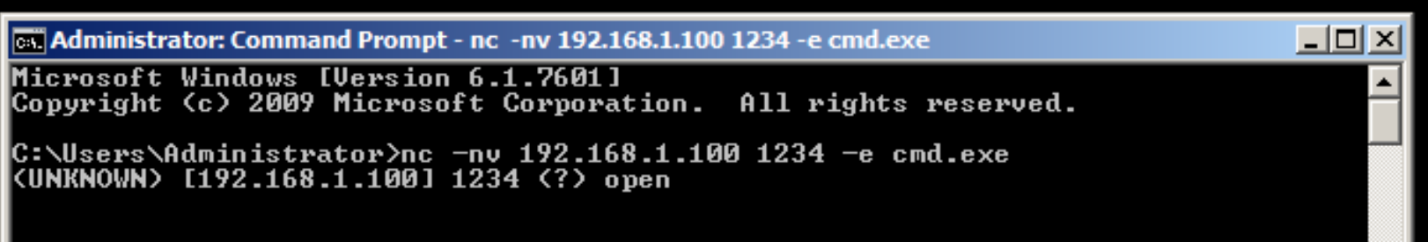

**Step 3:** Use the Kali machine terminal to run Windows commands.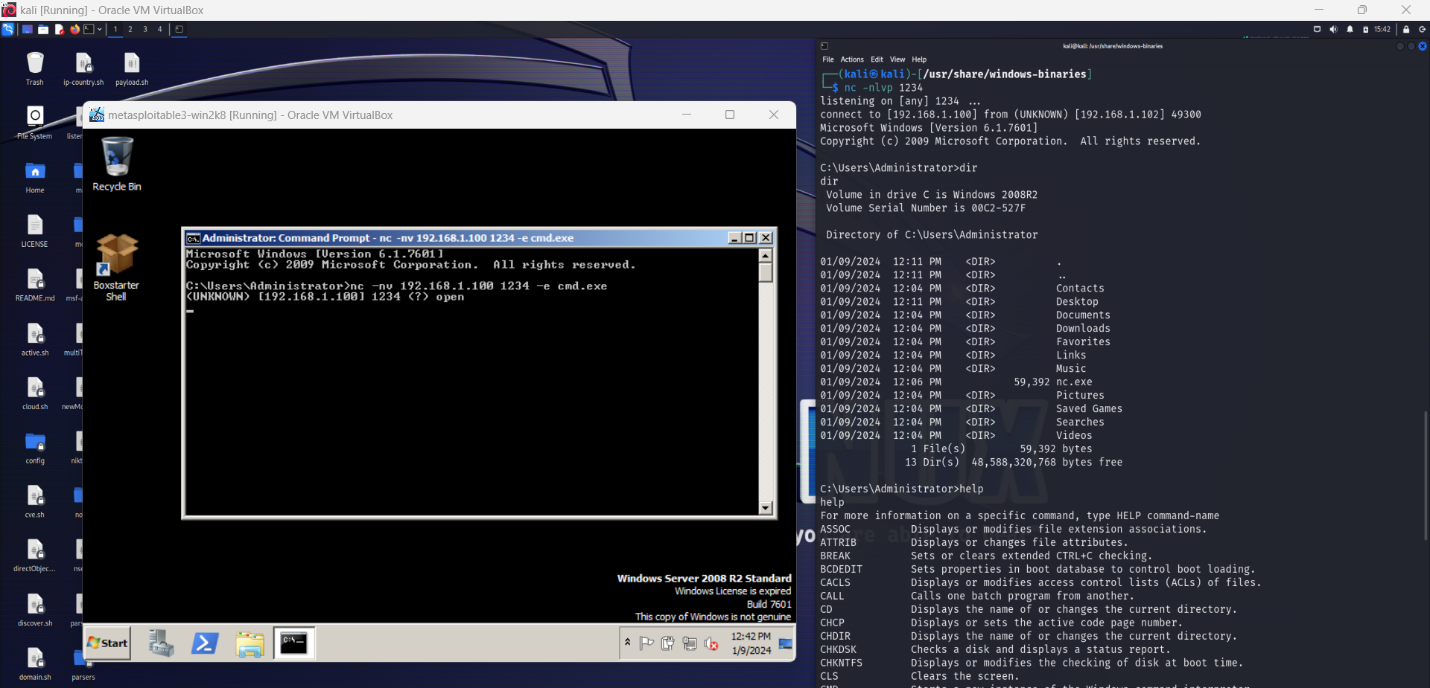

**Crafting Your Own Reverse Shell**

# Section 1: Writing a Reverse Shell Client

**Step 1:** Create a Python file using Nano:

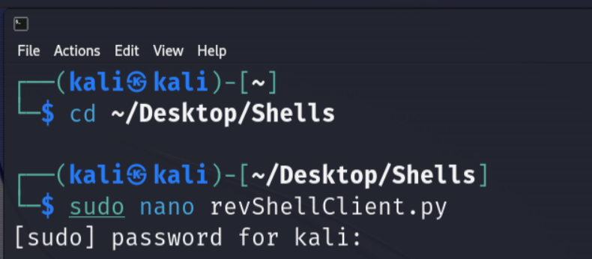

**Step 2:** Add the Python code to the nano program.

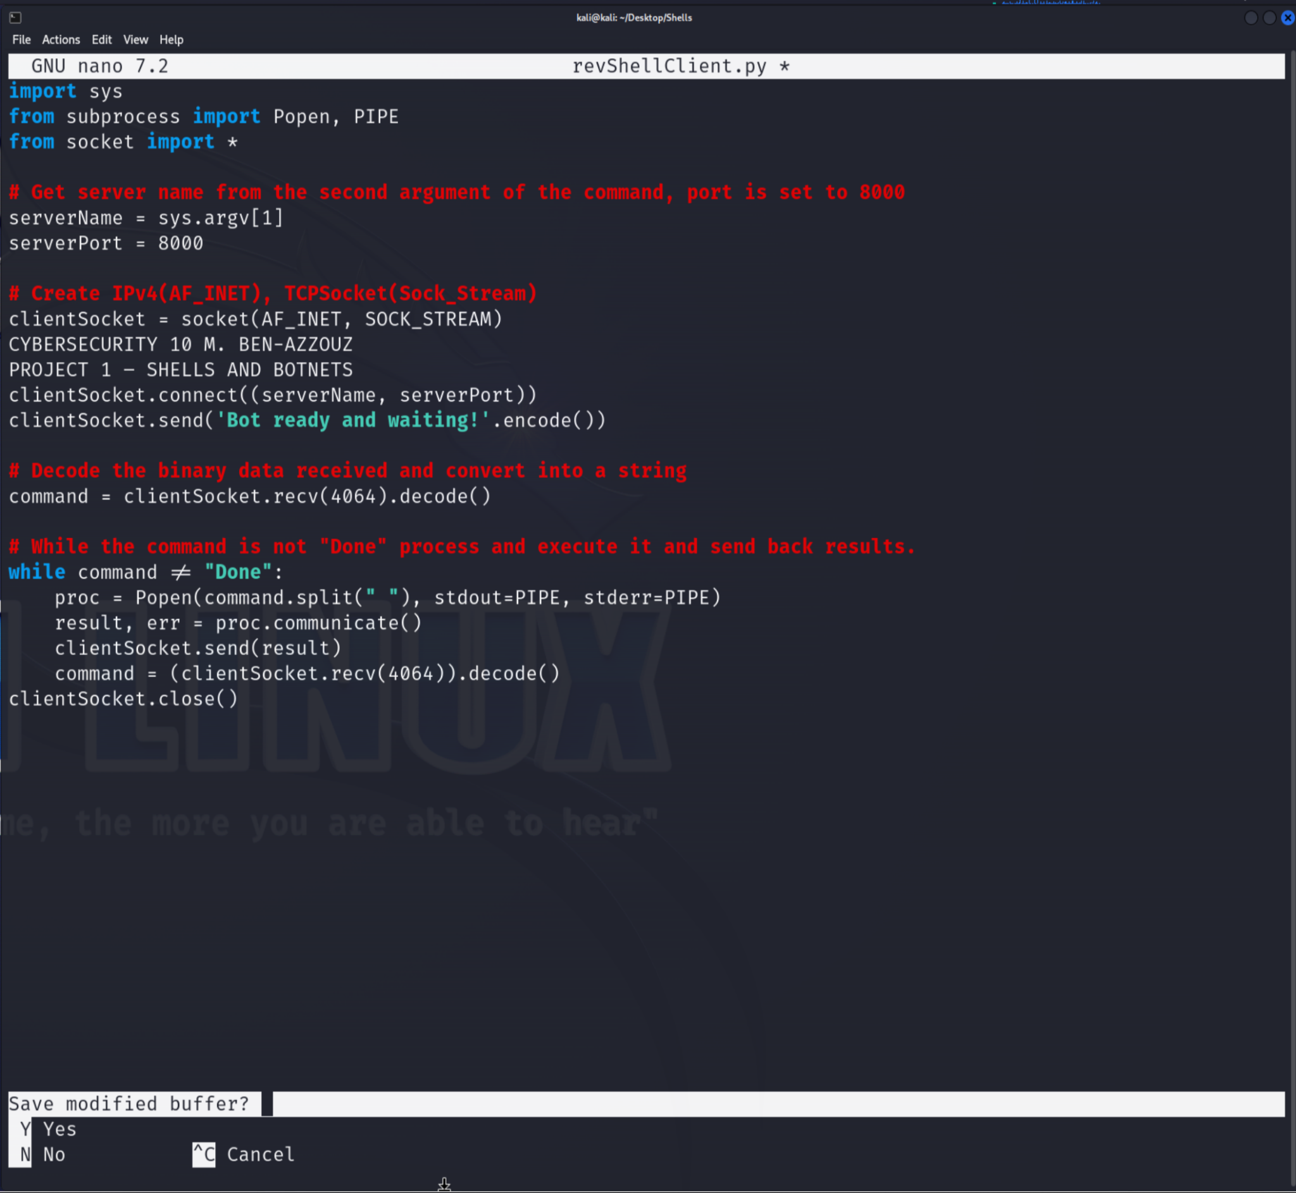

# Section 2: Writing a TCP Server (Listener)

**Step 1:** Create a Python file using Nano:

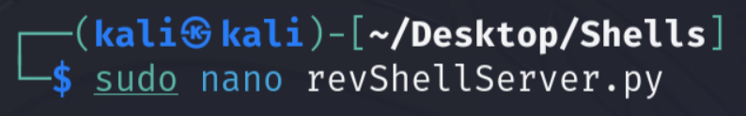

**Step 2:** Add the Python code to the nano program.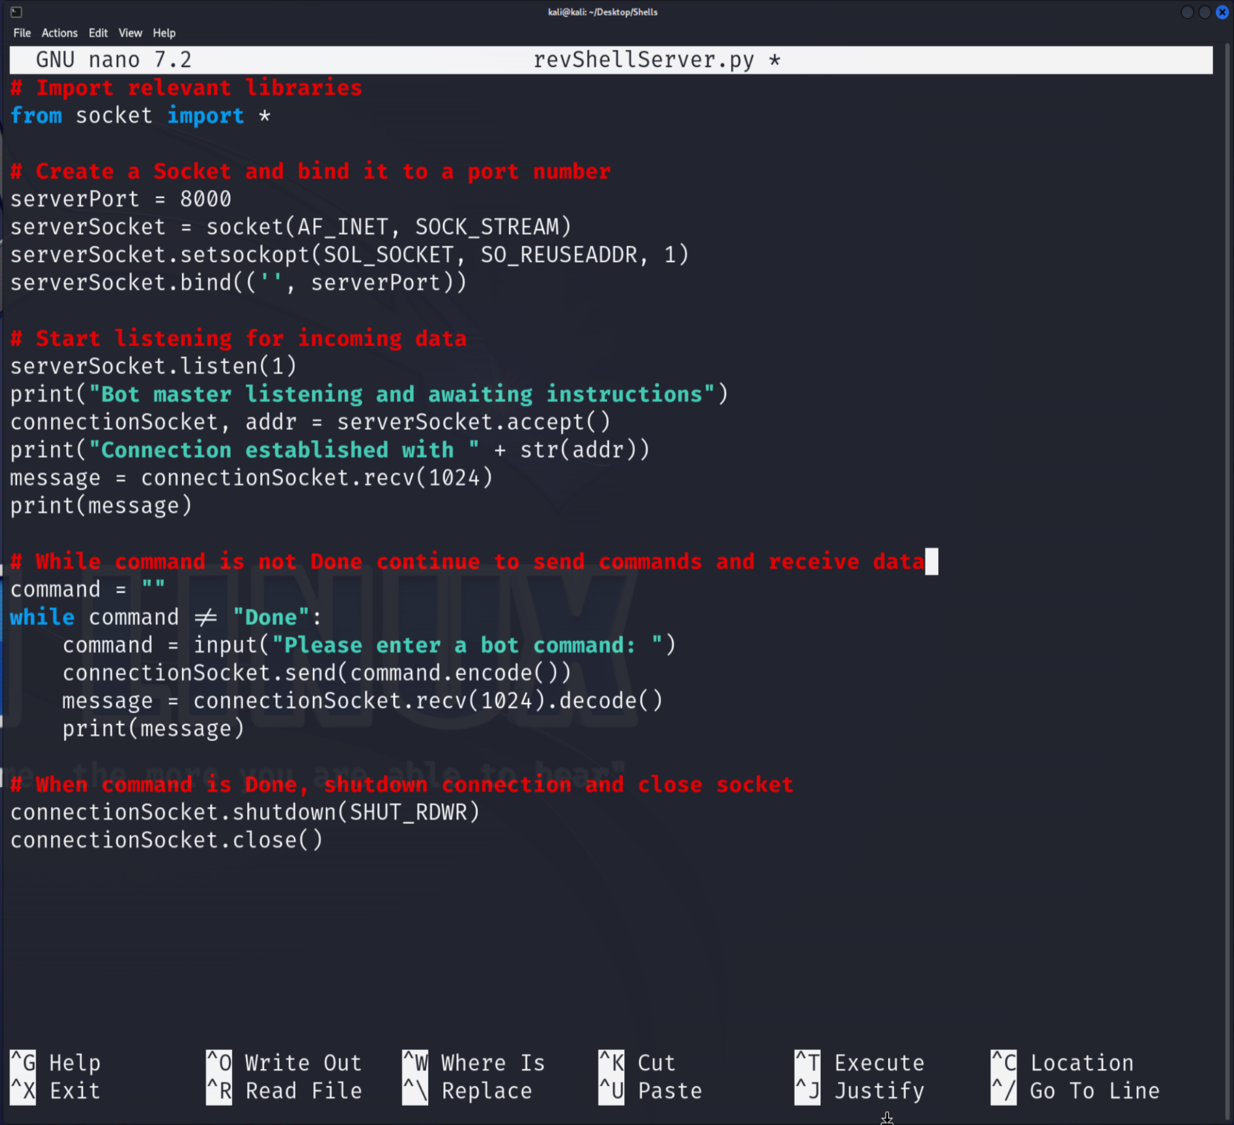

# Section 3: Load Reverse Shell onto the Target

**Step 1:** Start a web server. Then gain access to Metasploitable through ftp connection.

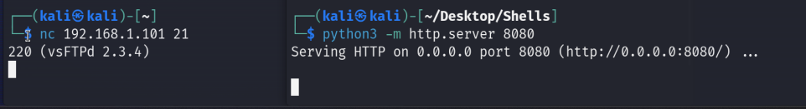

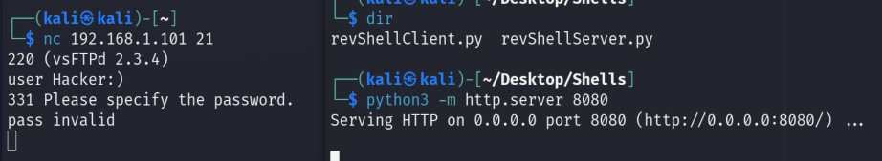

**Step 2:** Create a folder on the Metasploitable device and send the Python file to that device.

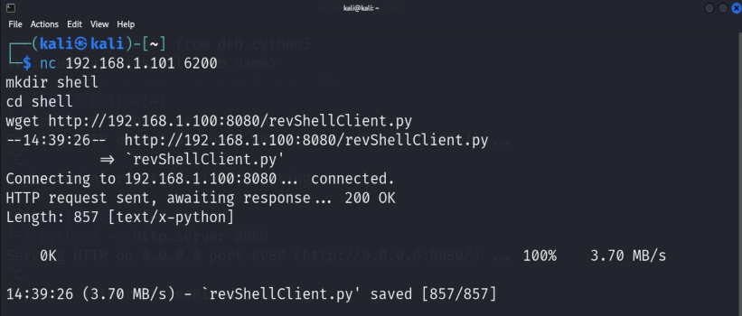

**Step 3:** Start the client and server shells on their respective devices and test commands to confirm a successful connection.



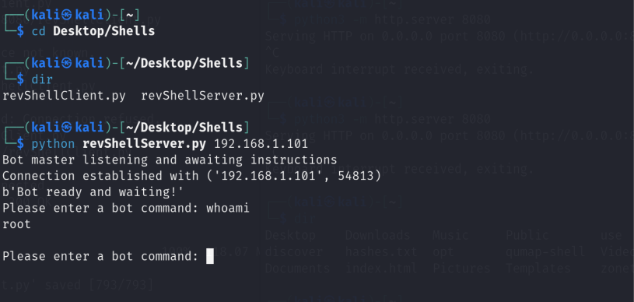

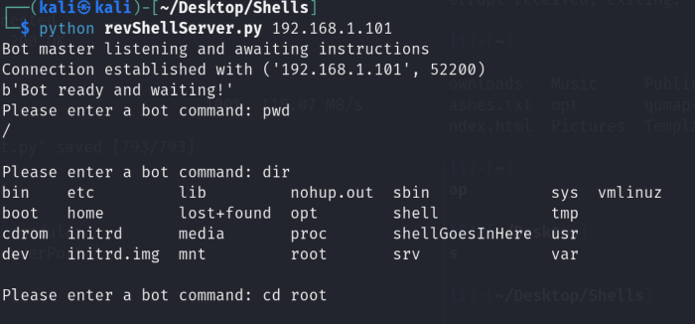

# Section 4: Botnets

**Step 1:** Create a file and insert the text “ping 172.217.9.206” in the file.

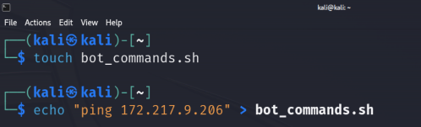

**Step 2:** Create a bot client.



**Step 3:** Use the client to ping a server.

